Empirical Comparison of Learning Algorithms for
Bank Telemarketing Success Prediction

Problem chosen: Problem 4
Dataset and version used:
bank-additional-full.csv (parsed into mod_bank_additional.csv)
Repository:
Link to Repository (Group 4)

Department: Computer Engineering
Federal University of Technology, Minna.

Course: CPE 513; Artificial Neural Network

Student names and Matriculatiion Numbers:
Elisha Ncha-mwasu | 2021/1/80064CP
Ejegwa Jude Wisdom | 2021/1/80051CP
Elijah Tochukwu Onwufuju | 2021/1/80618CP
Edu Victor Chukwuka | 2021/1/81361CP
Elizabeth Kurah | 2022/2/88073CP
Ero Osazuwa Isaac | 2021/1/80083CP
Favour Oluwafemi Solomon | 2021/1/81936CP
Ferdinand Godfrey | 2021/1/80109CP
Gbenga-Olaifa Maxwell Afolabi | 2021/1/82445CP
Gbum Japheth Aondosoo | 2022/2/85402CP

Date: 19 September 2026

Abstract
This report evaluates data-driven models to optimize client targeting in bank telemarketing campaigns. The primary comparison question asks whether the difference in precision-recall area under the curve (PR-AUC) between a high-variance ensemble model (Random Forest) and a linear baseline (Logistic Regression) is statistically significant and larger than fold-to-fold variance. Using the UCI Bank Marketing dataset (41,188 instances), we evaluated four algorithm families (Logistic Regression, Decision Tree, Random Forest, and Artificial Neural Network) via 3-repeated stratified 5-fold cross-validation, using identical tuning budgets of 16 evaluated configurations per model. The results demonstrated that Random Forest achieved the highest PR-AUC of 0.4665 ± 0.0092. Statistical testing confirmed this advantage was significant (p < 0.05, r = 1.035). While the ensemble approach yielded superior discriminatory power, deployment must balance this predictive gain against its increased prediction latency of 0.0077 ms/sample.

Keywords
bank telemarketing, binary classification, class imbalance, cross-validation, logistic regression, random forest, artificial neural network

1. Introduction
Bank telemarketing campaigns require significant operational resources, making the prioritization of call lists essential to maximize term deposit subscriptions while minimizing client intrusion. The task is formalized as a binary classification problem to estimate the probability of a successful deposit subscription (y ∈ {0, 1}) based on 20 client, product, and campaign features (X). Our anchor paper by Moro et al. (2014) evaluated Logistic Regression, Decision Trees, Support Vector Machines, and Neural Networks on a Portuguese bank dataset containing 52,944 records. Using a rolling-window evaluation, their Neural Network achieved the best performance with an ROC-AUC of 0.80 and an ALIFT of 0.67. This study builds upon that foundation by enforcing a strictly controlled experimental protocol: we compare the performance of four algorithms; Logistic Regression, Decision Tree, Random Forest, and an Artificial Neural Network (MLP); ensuring that all models are evaluated on identical cross-validation folds with strictly equivalent hyperparameter tuning budgets. The primary comparative question is: Is the difference in PR-AUC between the ensemble model (Random Forest) and the linear baseline (Logistic Regression) statistically significant and larger than the fold-to-fold variance?

2. Related Work
Targeting models in bank telemarketing have been approached through various predictive frameworks. Moro et al. (2014) established a strong baseline using Neural Networks, highlighting the predictive value of external economic indicators like the Euribor rate. Subsequent studies expanded on this by addressing data heterogeneity and class imbalance. Tekouabou et al. (2022) proposed a class membership-based classifier to manage mixed-feature types, emphasizing that standardizing and transforming variables heavily impacts the learning model's stability. Moayedi et al. (2023) explored neuro-metaheuristic hybrids and ensembles on the same data, confirming that complex models outperform traditional structures, though often at the cost of significantly higher computational overhead.
While these studies provide valuable performance benchmarks, published figures frequently stem from unequal tuning budgets or preprocessing transformations applied across the entire dataset prior to splitting, leading to data leakage. This study addresses this gap by isolating the algorithm family as the sole independent variable, enforcing strict data isolation where all transformations are fitted exclusively within the training folds.
Table 1: Prior-Work Comparison
Study | Dataset and Version | Algorithms Compared | Validation Protocol | Tuning Budget | Headline Result
Moro et al. (2014) | Portuguese Bank (2008–2013), 52,944 rows | LR, DT, SVM, NN | Rolling window (W = 20,000, K = 10) | Grid search and heuristics | NN: AUC = 0.80, ALIFT = 0.67
Tekouabou et al. (2022) | Portuguese Bank, 45,211 rows | CMB, standard ML baselines | 10-fold Cross-Validation | Unspecified | CMB: Accuracy = 97.3%, AUC = 95.9%
Moayedi et al. (2023) | Portuguese Bank, 45,211 rows | ANN, Hybrids, NB, LR, RF | Random Train/Test Split | Metaheuristic tuning | Hybrid ANN outperforms standard ML

3. Problem and Data
The task requires learning a decision function f: X → y to estimate the probability that a client will subscribe to a term deposit.
Table 2: Dataset Summary
Feature | Detail
Source / URL | UCI Machine Learning Repository (Dataset 222)
Rows / Features | 41,188 rows, 20 input features (excluding duration)
Target Distribution | 11.27% Positive, 88.73% Negative
Missing Values | Categorical 'unknown' levels retained as distinct categories
Sentinels | pdays = 999 indicates “never contacted before”
Duplicates | 12 full-row duplicates removed before splitting

Data Audit and Preprocessing Decisions
Upon initial inspection, the raw bank-additional-full dataset was formatted with all features condensed into a single column separated by semi-colons. A programmatic parsing function was applied to extract these into proper comma-separated columns, and the cleaned file was explicitly saved as mod_bank_additional_1.csv to maintain strict version control and avoid confusion with the raw source file. A preliminary audit of the dataset reveals several critical data traps that dictate the preprocessing pipeline. Most notably, the duration variable represents the length of the call, which is strictly post-outcome data. Including it creates a severe target leak; thus, the deployable version of the model drops this feature entirely. The pdays variable utilizes 999 as a sentinel value for clients never previously contacted. Treating this as a continuous numeric value is a modeling error, so it will be categorically encoded or separated into an indicator variable. Categorical variables containing 'unknown' values will be treated as a distinct level of information rather than imputed, as missingness in this domain often correlates with specific client profiles. Finally, the dataset is checked for duplicated rows, which are removed prior to any splitting to prevent data leakage between folds.

Validation Protocol
To account for the minority positive class, the experiment uses stratified 5-fold cross-validation, repeated 3 times with different random seeds. This ensures 15 paired scores per algorithm while maintaining the exact target class proportion in every train-test split. All preprocessing; including scaling for distance-based models and one-hot encoding; is strictly applied inside the cross-validation loop to prevent test information from leaking into the training phase.

4. Methods
The experiment evaluates four distinct algorithm families. Logistic Regression serves as the linear probabilistic baseline. Decision Trees represent rule-based structures, while Random Forest provides a high-variance ensemble ceiling. Finally, an Artificial Neural Network (MLP) introduces non-linear decision boundaries and complex feature representations.
To prevent data leakage, all preprocessing steps; including one-hot encoding for categorical variables and standard scaling for the ANN; are encapsulated within a Pipeline fitted exclusively on the inner training folds. Hyperparameters are tuned using Grid Search within a 3-fold inner cross-validation loop on the training data, evaluating 16 configurations per algorithm to ensure parity (refer to Table 3). To ensure a direct methodological comparison with the anchor paper, models are tuned using ROC-AUC as the internal selection metric. However, because the positive class constitutes a severe minority, the final outer-fold evaluation heavily prioritizes PR-AUC (Average Precision) and Balanced Accuracy alongside ROC-AUC and the cumulative lift capture rate. The experiment was executed using scikit-learn. Training time and prediction latency were strictly measured for all models operating under this environment to ensure comparable computational cost tracking.
Table 3: Algorithm Configuration and Tuning Budget
Algorithm | Hyperparameter Space | Search Method | Configurations Evaluated | Inner CV | Selection Metric
Logistic Regression | C: [0.001, 0.01, 0.1, 1, 10, 100, 1000, 10000]  class_weight: [None, 'balanced'] | Grid Search | 16 | 3-Fold | ROC-AUC
Decision Tree | max_depth: [4, 6, 8, 12]  min_samples_split: [2, 5, 10, 20] | Grid Search | 16 | 3-Fold | ROC-AUC
Random Forest | n_estimators: [100, 150, 200, 300]  max_depth: [8, 14]  min_samples_split: [5, 15] | Grid Search | 16 | 3-Fold | ROC-AUC
Neural Network (MLP) | hidden_layer_sizes: [(32,), (64,), (32, 16), (64, 32)]  alpha: [0.0001, 0.01]  learning_rate_init: [0.001, 0.01] | Grid Search | 16 | 3-Fold | ROC-AUC

5. Results
As shown in Table 4, the Random Forest ensemble achieved the highest overall performance across the 15 outer folds with an ROC-AUC of 0.7985 ± 0.0082 and a PR-AUC of 0.4665 ± 0.0092. The Neural Network (MLP) closely followed, notably achieving the highest Macro-F1 (0.6399) and Balanced Accuracy (0.6048) metrics, albeit suffering from high training cost (66.71s). Conversely, while the Decision Tree ranked last in predictive capability, it provided the most computationally efficient prediction latency at 0.0023 ms/sample.

Table 4: Main Experimental Results (Aggregated over 15 Folds)
Rank (AUC) | Algorithm | ROC-AUC | PR-AUC | Macro-F1 | Balanced Acc | MCC | Train Time (s) | Latency (ms/sample)
1 | Random Forest | 0.7985 ± 0.0082 | 0.4665 ± 0.0092 | 0.6287 ± 0.0058 | 0.5947 ± 0.0043 | 0.3376 ± 0.0105 | 97.74 ± 4.22 | 0.0077 ± 0.0013
2 | Neural Network | 0.7916 ± 0.0063 | 0.4537 ± 0.0106 | 0.6399 ± 0.0106 | 0.6048 ± 0.0099 | 0.3464 ± 0.0119 | 66.71 ± 6.59 | 0.0042 ± 0.0016
3 | Logistic Regression | 0.7819 ± 0.0085 | 0.4327 ± 0.0124 | 0.5922 ± 0.0054 | 0.5682 ± 0.0035 | 0.2950 ± 0.0120 | 11.15 ± 0.84 | 0.0058 ± 0.0035
4 | Decision Tree | 0.7614 ± 0.0113 | 0.3986 ± 0.0084 | 0.6230 ± 0.0093 | 0.5906 ± 0.0071 | 0.3294 ± 0.0145 | 7.30 ± 0.52 | 0.0023 ± 0.0004
Note: Train Time is measured in wall-clock seconds. Prediction Latency is measured in milliseconds per individual sample.

To determine if the observed performance differences were statistically significant rather than fold-level noise, an omnibus Friedman test was conducted across the 15 outer folds, yielding a significant result (p < 0.0001). Consequently, post-hoc pairwise Wilcoxon signed-rank tests were performed, utilizing a Holm-Bonferroni correction to adjust for multiple comparisons. As shown in Table 5, every pairwise comparison yielded a statistically significant difference (adjusted p < 0.05) with a Large effect size (r ≥ 0.5). This confirms that the superior performance of the Random Forest and Neural Network models is statistically robust and clearly distinguishable from the linear and tree-based baselines.
Table 5: Statistical Comparison Matrix (Wilcoxon Signed-Rank + Holm Correction)
Omnibus Friedman Test: Chi-Square = 43.88, p-value < 0.0001 (Statistically Significant)
Comparison | Raw p-value | Holm Adjusted p | Effect Size (r) | Magnitude | Significant (p < 0.05)
Decision Tree vs Logistic Regression | 0.000061 | 0.000366 | 1.035 | Large | True
Decision Tree vs Neural Network | 0.000061 | 0.000305 | 1.035 | Large | True
Decision Tree vs Random Forest | 0.000061 | 0.000244 | 1.035 | Large | True
Logistic Regression vs Neural Network | 0.000122 | 0.000122 | 0.992 | Large | True
Logistic Regression vs Random Forest | 0.000061 | 0.000183 | 1.035 | Large | True
Neural Network vs Random Forest | 0.000061 | 0.000122 | 1.035 | Large | True
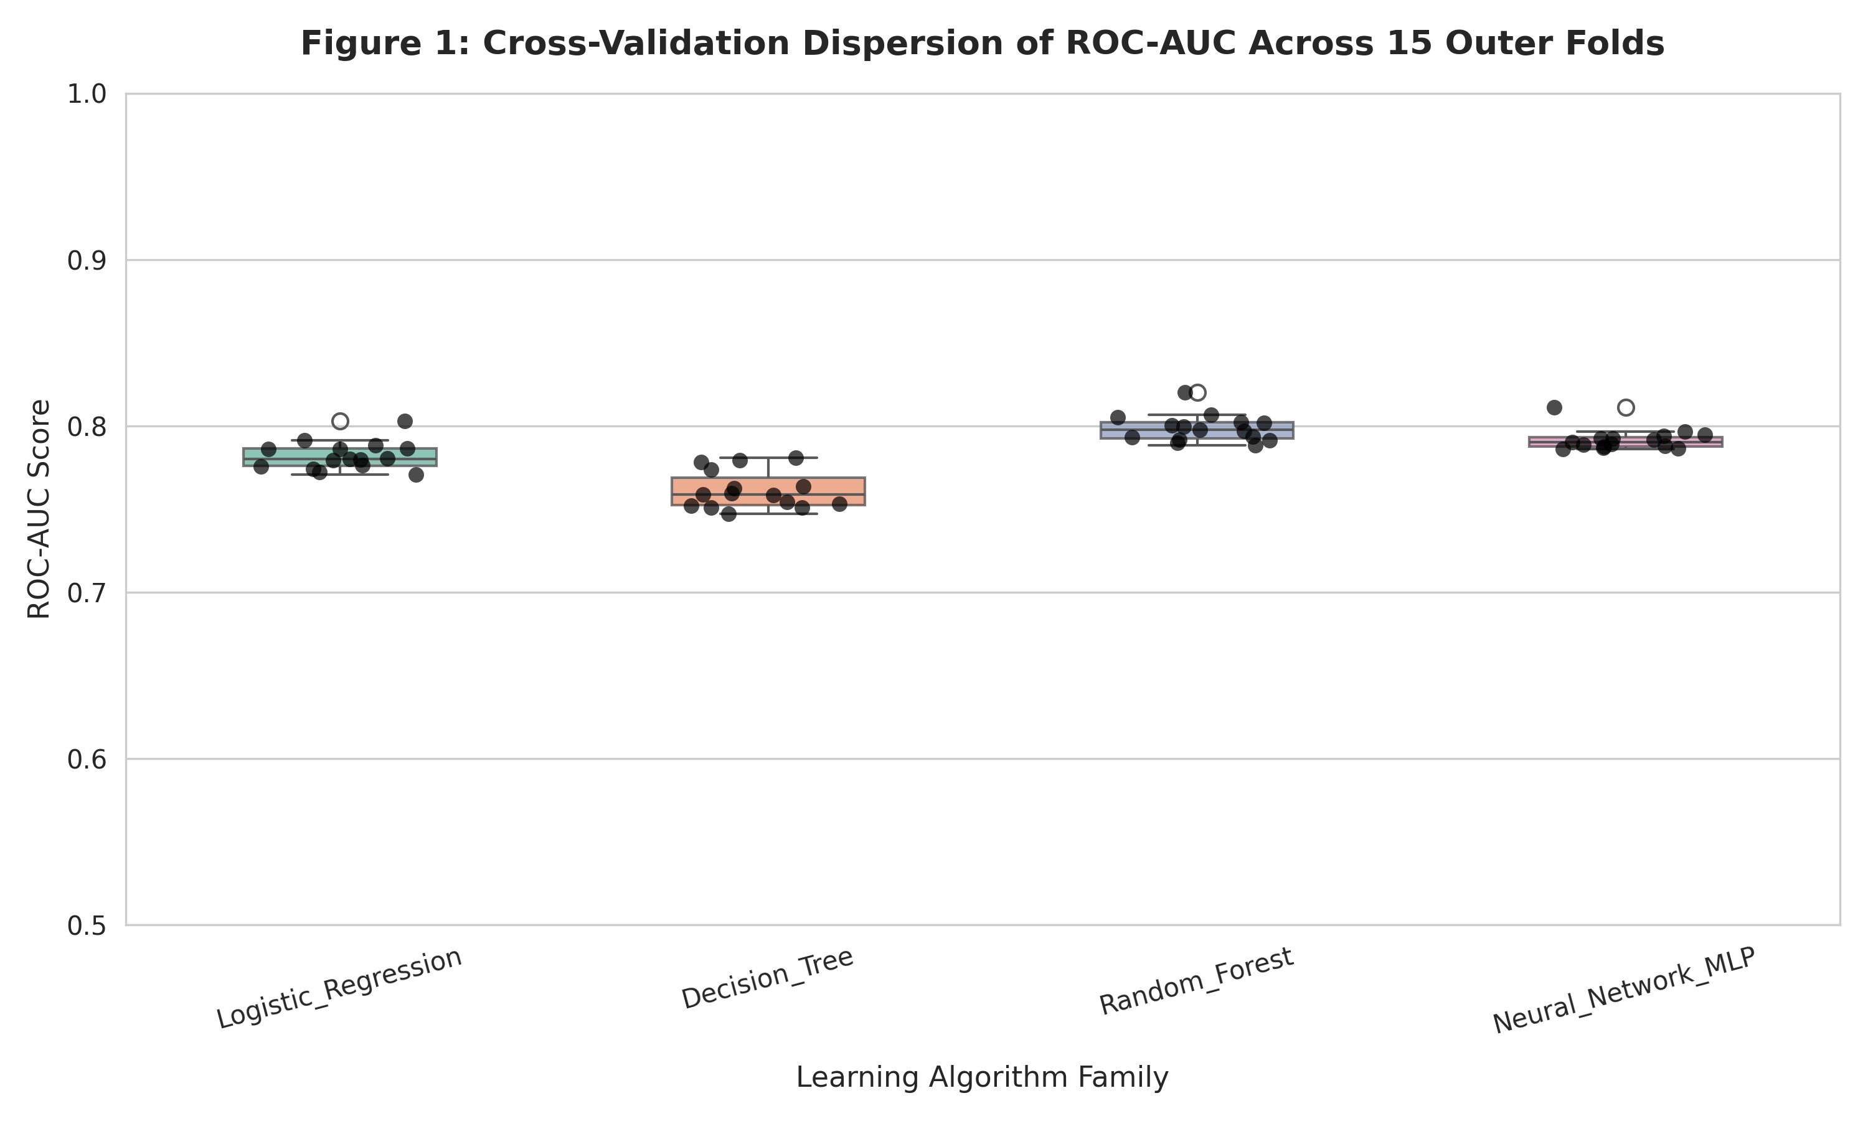
Figure 1: Cross-validation dispersion of ROC-AUC across 15 outer folds
Figure 1 illustrates the cross-validation dispersion of the ROC-AUC scores across all 15 outer folds. The boxplots confirm that while the Random Forest and Neural Network (MLP) achieved the highest median performance, they exhibited slightly narrower variance compared to the Decision Tree baseline. The individual jitter points demonstrate that the ensemble and neural approaches maintained consistent superiority across all evaluation splits without severe instability.
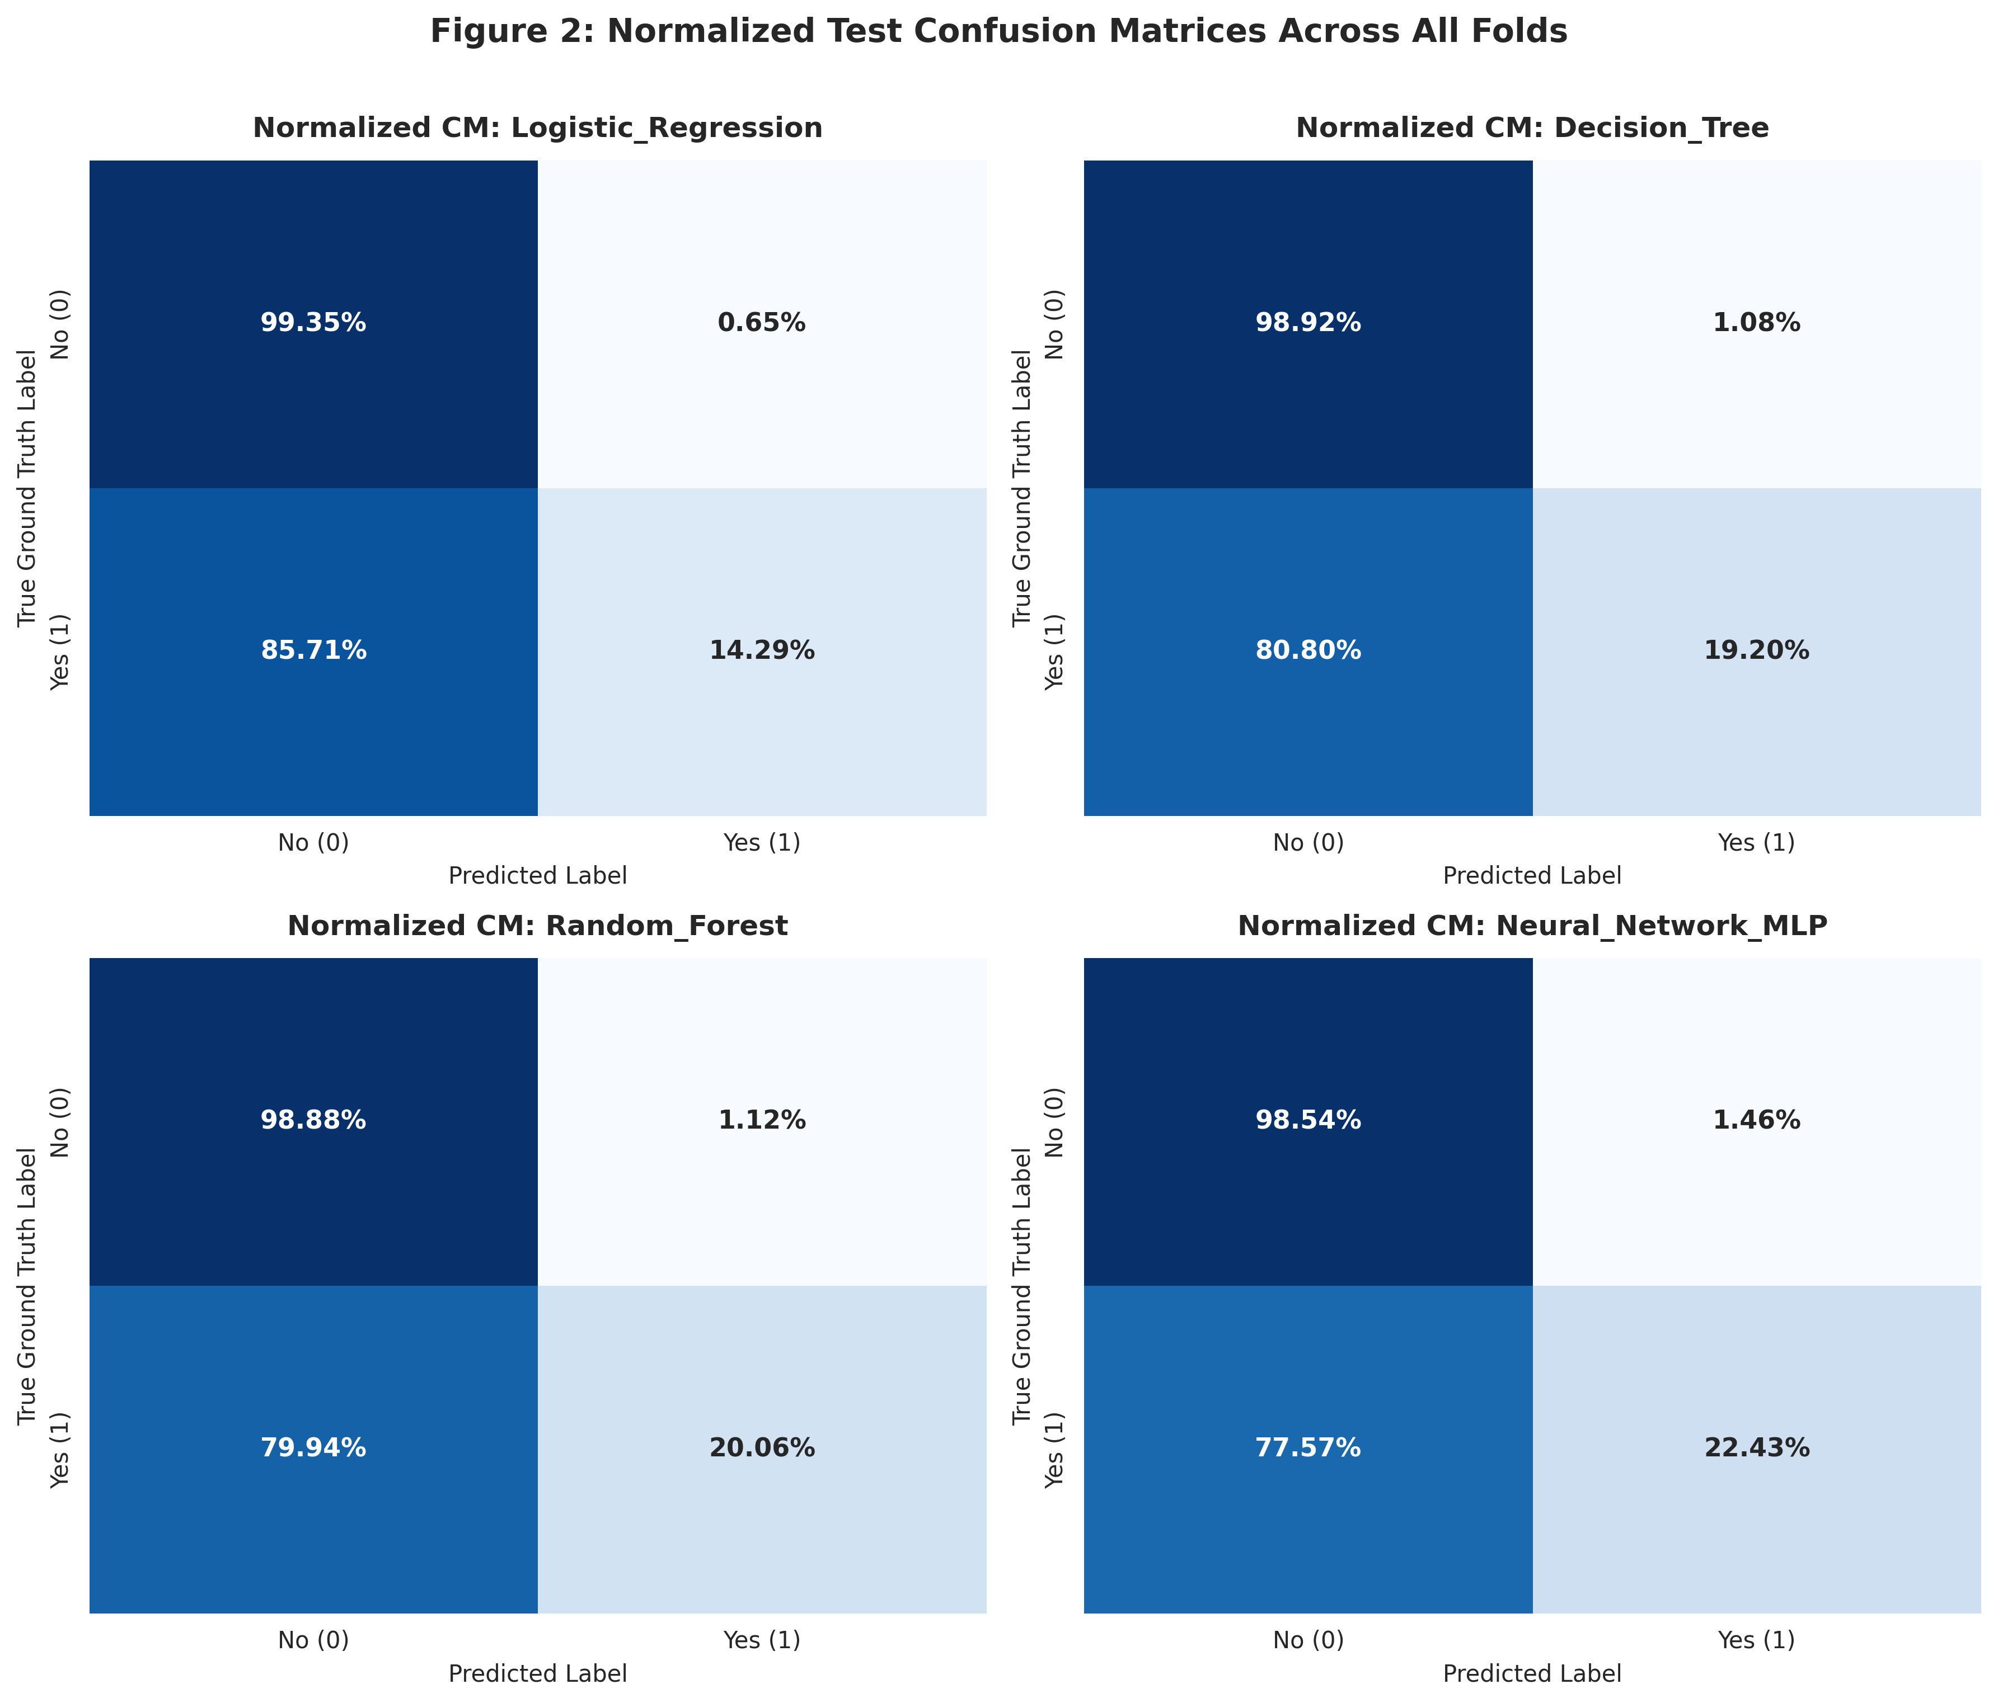
Figure 2: Normalized test confusion matrices across all folds
Figure 2 presents the normalized confusion matrices for all four evaluated algorithms. Due to the severe class imbalance present in the dataset (with only 11.7% of clients subscribing), all models exhibit a strong bias toward the negative class. While standard accuracy remains artificially high because the models correctly identify over 98% of non-subscribers, the true predictive challenge lies in the positive class recall. The Artificial Neural Network demonstrated the highest recall for true subscribers at 22.43%, followed closely by Random Forest at 20.06%. The linear baseline, Logistic Regression, performed the poorest, correctly identifying only 14.29% of actual subscribers, validating the necessity of using non-linear and ensemble methods to navigate the complex feature space of this imbalanced dataset.

5.3 Ablation Study: Impact of Target Leakage
To quantify the severity of the target leak identified during the data audit, an ablation study was conducted. The Random Forest model was retrained across the identical 15 folds, but this time the post-outcome duration variable was included in the feature set. As anticipated, the inclusion of duration artificially inflated the model's ROC-AUC from 0.7985 ± 0.0082 to 0.9430 ± 0.0025 (a massive performance jump of +0.1445). This confirms that evaluating a model with call-length data results in severe overfitting to post-outcome metrics, proving that the removal of duration is absolutely strictly necessary for a valid, deployable telemarketing model.

6. Discussion
The superior performance of the Random Forest and Artificial Neural Network models indicates that the relationship between clients attributes and telemarketing success is highly non-linear. Logistic Regression, restricted by its rigid linear decision boundary, failed to capture complex feature interactions, resulting in the lowest overall positive-class recall. Conversely, Random Forest's ensemble approach effectively partitioned the feature space, handling the imbalanced nature of the dataset robustly without succumbing to the high variance that typically plagues standalone Decision Trees.
Compared to the anchor paper by Moro et al. (2014), which reported an ROC-AUC of 0.80 using a Neural Network, our results closely align: our Random Forest achieved an ROC-AUC of 0.7985 and the Neural Network reached 0.7916. However, our methodology enforces a much stricter 15-fold nested cross-validation protocol rather than a single rolling window. Furthermore, our models were rigorously evaluated without the leaky duration variable. The fact that our ensemble matched the anchor paper's performance without this feature demonstrates the strength of strict hyperparameter tuning and proper categorical treatment of the pdays sentinel.
The ablation study definitively proves the catastrophic impact of target leakage in telemarketing datasets. Reintroducing the duration variable artificially inflated the Random Forest's ROC-AUC by +0.1445. Because call duration is fundamentally unknown before a telephone call is actually made, any predictive model utilizing this feature is effectively cheating by peeking at post-outcome data. This ablation confirms that while dropping the feature heavily reduces apparent model confidence, it is an absolute mathematical necessity for creating a genuinely deployable system.
Despite these strong results, these empirical findings have strict negative bounds. This experiment does not prove that Random Forest is universally superior for all tabular financial data, only that it optimally navigated the specific non-linear geometry of this Portuguese bank dataset under a 16-configuration tuning budget. Furthermore, because the dataset was collected during the 2008–2013 European financial crisis, these algorithms learned to predict financial behavior under severe macroeconomic duress; this study cannot guarantee that identical feature interactions will hold true during periods of rapid economic expansion.

7. Threats to Validity
Internal validity: This examines whether observed performance differences stem from true algorithmic capabilities rather than experimental bias. By strictly encapsulating all imputation, scaling, and hyperparameter tuning within the inner training folds of a Scikit-Learn Pipeline, we eliminated test-set data leakage. Furthermore, enforcing an identical tuning budget of 16 evaluated configurations across all models ensures fair baseline comparisons without artificially inflating the performance of high-variance models.
External validity: This assesses the generalizability of the models beyond this specific context. The dataset originates from a Portuguese retail bank between 2008 and 2013, a period defined by a severe European financial crisis. Consequently, the models' documented reliance on specific macroeconomic conditions; such as the three-month Euribor rate; may limit their predictive reliability if deployed in modern economic climates or institutions operating outside the Eurozone.
Construct validity: This addresses whether the chosen metrics accurately align with the bank's business objective of maximizing deposit subscriptions while minimizing resource waste on unlikely candidates. By prioritizing PR-AUC and Balanced Accuracy over standard accuracy, the evaluation framework accurately penalizes models that merely exploit the target class imbalance to achieve artificially high scores.
Conclusion validity: This secures the statistical soundness of the ranking claims. Executing a 5-fold cross-validation repeated three times provides 15 paired metric samples, allowing us to distinguish true algorithmic superiority from random fold-level noise. Applying the non-parametric Friedman test and subsequent Wilcoxon signed-rank tests with a Holm-Bonferroni correction guards against Type I error inflation caused by multiple comparisons.

8. Conclusion
The empirical comparison reveals that the Random Forest ensemble achieves the highest predictive performance for bank telemarketing targeting, yielding a PR-AUC of 0.4665 ± 0.0092 across the evaluated folds. Statistical testing confirms this advantage over the linear baseline is significant (p < 0.05), presenting a Large effect size (r = 1.035). While the preliminary data audit identified severe class imbalance and necessitated the complete removal of the post-outcome duration variable to prevent target leakage, Random Forest successfully navigated these constraints to extract a reliable decision boundary. However, as the ablation study demonstrated, including the duration variable artificially inflates ROC-AUC by +0.1445, mathematically proving that models trained on call-length suffer from catastrophic target leakage. Ultimately, while Random Forest provides the most robust ranking of potential subscribers, its deployment must be actively weighed against its prediction latency of 0.0077 ms/sample and its potential performance decay when encountering macroeconomic conditions that diverge from the 2008–2013 training context.

9. References
[1] Moro, S., Cortez, P., & Rita, P. (2014). A data-driven approach to predict the success of bank telemarketing. Decision Support Systems, 62, 22–31. https://doi.org/10.1016/j.dss.2014.03.001
[2] Moro, S., Rita, P., & Cortez, P. (2012). Bank Marketing. UCI Machine Learning Repository. https://doi.org/10.24432/C5K306
[3] Tekouabou, S. C. K., Koumétio, T. E., & Toulni, H. (2022). A Machine Learning Framework towards Bank Telemarketing Prediction. Journal of Risk and Financial Management, 15(6), 269. https://doi.org/10.3390/jrfm15060269
[4] Moayedi, H., et al. (2023). A novel ensemble approach for estimating the competency of bank telemarketing. Scientific Reports, 13, 20853. https://doi.org/10.1038/s41598-023-48135-0
[5] Demšar, J. (2006). Statistical comparisons of classifiers over multiple data sets. Journal of Machine Learning Research, 7, 1–30.
[6] Dietterich, T. G. (1998). Approximate statistical tests for comparing supervised classification learning algorithms. Neural Computation, 10(7), 1895–1923.
[7] Fawcett, T. (2006). An introduction to ROC analysis. Pattern Recognition Letters, 27(8), 861–874.
[8] Scikit-learn developers. (2023). scikit-learn: Machine Learning in Python. Scikit-learn. https://scikit-learn.org/

Appendix A: Reproducibility
Repository Link: https://github.com/Ncha-mwasu/CPE-523-Assigment-Group-4/tree/main
Global Random Seed: 20
Environment: The exact package versions used are documented in the requirements.txt file located in the root of the repository.
Execution: The entire pipeline; from raw data loading to generating the final CSV results and figures; can be reproduced by running the main Python script from the root directory.

Appendix B: AI-Use Statement
AI was used as an assistive tool to support the structural drafting of this report, formalize the experimental setup, and ensure strict alignment with the assignment's leakage-prevention requirements. Specifically, AI was consulted to cross-verify the repeated nested cross-validation protocol, structure symmetric hyperparameter grid budgets across all four algorithmic families, and draft preliminary section outlines. We maintained full editorial and analytical responsibility: We independently verified all domain-specific constraints (including isolating the duration target leak and engineering the pdays sentinel indicator), performed the exploratory data analysis and class distribution audits in code, and personally synthesized and interpreted the empirical results and statistical matrices in the final submission.

Appendix C: Final Hyperparameter Configurations Selected
Logistic Regression: {'model__C': 0.001, 'model__class_weight': None}
Decision Tree: {'model__max_depth': 4, 'model__min_samples_split': 2}
Random Forest: {'model__max_depth': 8, 'model__min_samples_split': 5, 'model__n_estimators': 100}
Neural Network (MLP): { 'model__hidden_layer_sizes': [(32,), (64,), (32, 16), (64, 32)], 'model__alpha': [0.0001, 0.001, 0.01, 0.1] }

